PROGRAM TITLE
ASSET MANAGEMENT

PROCESS TITLE
Warehousing of Materials and Supplies

- SCOPE

This policies and procedures manual establishes policies, systems, procedures and controls on warehousing of materials and supplies. All duties and responsibilities stated in this manual are not exclusive to the personnel’s designated responsibilities in this process title.

- OBJECTIVES

- To ensure that materials and supplies are properly warehoused and monitored.
- To ensure that all receipts and issuances of materials and supplies are recorded and approved by authorized personnel.
- To ensure that physical inventory is properly performed, inventory valuation methods are appropriate, inventory records reflect actual quantities on hand and any adjustments are investigated and adjusted accordingly.
- To clearly define the duties and responsibilities of all personnel involved in this process title.

- PERSONNEL INVOLVED

  - Issuing Warehouse Custodian

    - Safeguards materials and supplies under custody.
    - Evaluates the Materials Requisition Slip (MRS) and Materials Transfer Request (MTR).
    - Issues supplies/stocks based on duly approved MRS / MTR.
    - Inspects and counts the items purchased and delivered to the warehouse.
    - Prepares the following documents:
- Receiving Report (RR)
- Notice of Discrepancy (ND)
- Materials and Supplies Issuance Slip (MSIS)

    - Informs the Warehouse Supervisor of under-delivery, over-delivery, damaged goods, and/or difference in specification of items delivered to the Warehouse.
    - Receives the Materials and Supplies Return Slip (MSRS).
    - Receives the unused materials and supplies returned by the Engineering Department.
    - Receives the Materials Transfer Request (MTR) from the Requesting Warehouse Custodian.

  - On-Site Representative

    - Receives the materials and supplies delivered directly to end user outside warehouse premises.
    - Stamps supplier’s documents (i.e. delivery receipt (DR), official receipt (OR), charge invoice (CI), etc.) upon receipt of materials and supplies.
    - Sends scanned copies of duly stamped “Received” copies of supplier’s documents to the respective Warehouse Custodian where the PO was forwarded.
    - Sends, through courier services, the hard copies of the supplier’s documents to the respective Warehouse Custodian where the PO was forwarded.

  - Warehouse Office Staff

    - Encodes the details of the documents used in the receipt, issuance and transfer of materials and supplies into the Warehousing System.
    - Monitors the safety stock level of materials and supplies.
    - Files the documents forwarded to the warehouse (i.e. RR, MRS, MTR, MSIS).

  - Requisitioning Personnel / Department

    - Duly fills out the details in the MRS.
    - Receives the requested items by signing in the “Received by” portion of the MSIS.

  - Requesting Warehouse Custodian

    - Prepares the MTR.
    - Receives the items delivered from the requested warehouse.

  - Warehouse Supervisor

    - Verifies the following documents:
- MSIS
- STR
- RR
- ND

    - Inquires with the Purchasing Department of actions to be taken on under-delivery, over-delivery, damaged goods, and/or difference in specification of items delivered to the Warehouse.
  - Guard on Duty

    - Checks the identification of the courier’s/supplier’s representative entering the warehouse and secures a copy of the Purchase Order and supplier’s documents (i.e. DR, SI, OR, etc.) from the representative.
    - Conducts routine inspection of vehicles entering the warehouse.
    - Stamps supplier’s DR with time-in and time-out and logs the same in the Logbook.
    - Inspects the items picked-up by the courier and compares with the details in the Gate Pass.

- KEY TERMS

  - Reorder point – The inventory level where purchase order should be places. Reorder point is the sum of lead time quantity and safety stock quantity. (refer to process title “Procurement of Materials and Services” for illustration in computing for the reorder point)

  - Safety stock – A margin in case of variations in normal usage and normal lead time. Hence, there is a safety stock for variation in usage and a safety stock for variations in time.

  - First-In First-Out Issuance – A method of issuance wherein the oldest inventory items are first issued.

- ACCOUNTS

Account Code | Account Title | Account Description
000-00-00-000-0000-1110-1502 | Materials and Supplies | This account is debited for purchases of materials and supplies.
000-00-00-000-0000-1110-1500 | Input Tax ^{[1]} | This account is debited to recognize the value added tax of purchased materials and supplies.
000-00-00-000-0000-7199-7902 | Accounts payable – clearing | This is an automatic credit entry in the system upon receipt of materials and supplies.
000-00-00-000-0000-2121-2036 | Withholding tax – Expanded ^{[1]} | This account is credited to recognize the expanded withholding tax of purchased materials and supplies.
 | Capital expenditures | This account is debited for issued materials and supplies used for routine vessel maintenance and other significant repairs.
000-00-00-000-0000-6174-6120 | Repairs and Maintenance – Materials | This is debited for issued material and supplies used for emergency and other minor repairs.
000-00-00-000-0000-6170-6080 | Office Supplies Expense | This account is debited for office supplies issued to requesting department.

- Note: The BIR rulings shall be checked from time to time for changes on the requirements and deadline.

- JOURNAL ENTRIES

  - To record receipt of materials and supplies from supplier

Account Code |  | Account Title |  | Dr. | Cr.
000-00-00-000-0000-1110-1502 |  | Materials and Supplies |  | xx
000-00-00-000-0000-1110-1500 |  | Input Tax |  | xx
000-00-00-000-0000-7199-7902 |  |  | Accounts Payable – Clearing |  | xx
000-00-00-000-0000-2121-2036 |  |  | Withholding Tax – Expanded |  | xx
 |  | #

  - To record issuance of materials and supplies for significant repairs (subject to capitalization policy under Capital Expenditures policies and procedures)

Account Code |  | Account Title |  | Dr. | Cr.
 |  | Capital expenditures |  | xx
000-00-00-000-0000-1110-1502 |  |  | Materials and supplies |  | xx
 |  | #

  - To record issuance of materials and supplies for minor repairs and maintenance

Account Code |  | Account Title |  | Dr. | Cr.
000-00-00-000-0000-6174-6120 |  | Repairs and maintenance – materials |  | xx
000-00-00-000-0000-1110-1502 |  |  | Materials and supplies |  | xx
 |  | #

  - To record issuance of office materials and supplies

Account Code |  | Account Title |  | Dr. | Cr.
000-00-00-000-0000-6170-6080 |  | Office supplies |  | xx
000-00-00-000-0000-1110-1502 |  |  | Materials and supplies |  | xx
 |  | #

- POLICIES

  - General Policies

    - Custody and recording of inventories shall not be performed by the same personnel.
    - Adequate storage space properly enclosed and protected shall be provided and qualified personnel should take charge of the warehouse. Moreover, those items stacked outside the warehouse should be provided with the necessary shelters for protection.
    - Unauthorized persons should not be allowed inside the warehouse. In no way shall the warehouse key be borrowed by personnel other than the warehouse custodian.
    - Warehoused materials should be properly arranged, systematically stacked and labeled to ease identification and traceability. Items in the warehouse may be segregated by type, sensitivity, usage, and ownership. As such, items held for other Companies, if any, should be properly labeled and physically segregated in the warehouse.
    - Warehoused materials should be arranged in a systematic manner allowing the warehouse custodian and the forklift to conveniently pass through sections inside the warehouse and locate items for pullout/issuance.
    - The First-in, First-out (FIFO) method of inventory issuance shall be employed, especially for those items that have expiry dates.
    - Proper charging should be observed on the issuance of materials and supplies (i.e. per department and/or per vessel).
    - Each department shall be responsible for the monitoring of the in and out of office materials and supplies issued to them. Safety stock and re-order points shall be considered in timing requests for materials and supplies.
    - Systematic measurement shall be employed on each class of items in the warehouse. As such, use of weighing scales and other means of measuring warehoused items may be employed.
    - Appropriate and adequate firefighting equipment shall be provided and placed on strategic locations around the warehouse. Moreover, highly flammable materials and hazardous materials should be placed in a separate and well ventilated storage area and must be properly labeled to ease identification.

    - Warehouse and all materials, equipment, etc. inside should be insured.
    - Any sign of pilferage, theft, robbery, losses or untoward incidents shall be reported immediately to the Warehouse Supervisor.
    - Smoking, eating and drinking inside the warehouse is strictly prohibited.

  - Receiving

    - All delivered, inspected and accepted materials, supplies, equipment, etc. shall be duly prepared with a Receiving Report (RR). The RR indicates the description of goods, the quantity received, the date received and other relevant data.
    - The RR shall be pre-numbered and printed sequentially.
    - All deliveries must be communicated to the Purchasing Department for confirmation. For delivery of materials and supplies, a representative from the Purchasing Department and the requesting department may accompany and witness the receiving process.
    - A Purchase Order (PO) must be presented by the supplier’s representative upon delivery of ordered materials and supplies. No deliveries shall be accepted without the presentation of a duly approved PO. Moreover, no deliveries shall be accepted without a copy of the supplier’s Delivery Receipt (DR).
    - No RR shall be prepared without duly approved Purchase Order (PO).
    - One RR shall be prepared for each delivery. However, if deliveries of materials partially done or additional materials are still to be delivered, all deliveries pertaining to the specific PO shall be monitored and one RR shall be prepared for every delivery of the said PO.
    - In cases of damaged, short, excess, and/or deliveries that do not conform to user’s specifications, a Notice of Discrepancy (ND) shall be prepared. Delivered materials, supplies, equipment, etc. which are found damaged or defective shall be rejected and returned to the supplier.
    - The Warehouse Custodian must inform the Purchasing Department for discrepancies in the quantity of items delivered. The details of the discrepancy shall then be communicated to the user department for inquiry on the acceptance of the orders. However, the supplier may replace the rejected deliveries as soon as possible and if the replacement will take a long time, the purchaser may order it to the next qualified supplier.
    - For short/partial/under deliveries, the Notice of Discrepancy shall be duly signed by the Purchasing Manager, with consent from the user department.
    - For over deliveries, the Notice of Discrepancy shall be duly signed by the approving officers of the MSPRF and the PO as indicated in section V.I.1, page 8 of the process title “Purchasing of Materials”, and the Finance Manager.

    - Orders for materials, supplies, equipment, etc. shall be received by the following personnel:
Items |  | Receiving Personnel
Materials, supplies, equipment, etc. in the warehouse | - | Warehouse custodian
Other materials, supplies, equipment, etc. requested by departments/vessels (direct delivery) | - | On-site representative at designated receiving sections/area

    - During emergency situations when the warehouse custodian/on-site representative is not available, an authorized personnel shall acknowledge the receipt of the items and issue the materials requested. As such, the authorized personnel shall be in-charge of the preparation of the RR and MSIS/STR and signs the “Received by” and “Released by” portion, respectively, for accountability. However, the related documents must be submitted/turned over to the warehouse custodian/on-site representative upon his return. Upon receipt of the documents and the RR and/or MSIS/STR, the warehouse custodian/on-site representative shall sign the “Prepared by” portion for proper documentation, actual verification, and accountability.
    - For items to be delivered directly to the vessel or end user department, an on-site representative shall be in-charge of the signing of the Delivery Receipt and receiving of other supplier’s documents. He shall also be responsible for the counting and inspection of the items received. If the items are delivered to a site with a warehouse, the warehouse custodian shall prepare the RR. Otherwise, the on-site representative shall stamp the supplier’s documents as received and forward the same to the warehouse department of respective office where the PO of the delivery was made to facilitate the preparation of the RR. Moreover, the on-site representative shall immediately send the hard copies of the documents (i.e. DR, SI, OR, etc.) to the Warehouse Custodian through mail.
    - Discrepancy in the specification and/or number of items received shall be immediately resolved with the supplier and the purchasing department.
    - A fuel sounding shall be conducted before and after the receiving of fuel. The policies and procedures for the tank sounding and fuel monitoring are stated in Section V.G, page 10 and Annex A, page 56 of the process title “Vessel Repairs and Maintenance”.

  - Monitoring

    - A monthly inventory report shall be submitted to the accounting department during the first week of the following month.

    - Slow moving, obsolete, scrap, damaged materials, etc. should be reported to management and disclosed in the inventory report for possible disposition and/or corrective action. Moreover, these items should be properly labeled and segregated. Evaluation on these items should be done quarterly.
    - A Materials and Supplies Disposal Form (MSDF) shall be prepared for every disposal of scrap materials and supplies. The manner and frequency of disposal shall be decided by the management duly supported with the MSDF.
    - Stock levels shall be monitored by the warehouse custodian to avoid out-of-stock situation. The Economic Order Quantity (EOQ) and reorder points shall be considered and monitored by the Warehouse Department.
    - There should also be a feedback (i.e. verbal or written) from the user department regarding the quality, remarks, etc. on the usage of materials (i.e. of a particular brand) forwarded to the warehouse custodian and to the Purchasing Department.
    - Office materials and supplies shall be monitored by each department using the Business Forms Monitoring Log.

  - Physical Inventory Verification

    - A physical inventory verification will be conducted at least once a year. However, cycle inventory verification (interim physical verification) may be conducted as the need arises. The accounting department shall be responsible for ensuring that the physical count is properly performed and segregation of duties is maintained throughout the inventory process. As such, no one person should have custody of the inventory and perform the related reconciliation at the same time.
    - The inventory verification shall be supervised by a team composed of representatives from the accounting department, warehouse department, and audit. However, physical count must not be conducted by the personnel with direct responsibility over the materials and supplies to be counted. For the annual inventory verification, this is done in conjunction with the annual audit performed by the external auditors.
    - Instructions to participants involved in the physical inventory process should be in writing and include the following information:
- Location, date, and start time.
- Team designation and roles of key team members.
- Assignment of teams to specific areas/vessels.
- Detailed instructions including examples on how to complete the recording of the physical counts.
- Guidance on how to designate/identify possible obsolete, damaged, or scrap inventories for later review.
- Identification of inventory designated as that held for other affiliates or as the case may be (in cases in which the inventory is physically segregated).
- Required outfits and safety paraphernalia.

    - User departments must be notified in advance of the planned inventory count. Moreover, employees must be informed of the schedule of the count to provide sufficient time in planning the count.
    - The warehouse must be prepared before the start of the count to facilitate ease of counting.
- Similar items shall be grouped and arranged together.
- Hazards (i.e. wet floor, falling objects, etc.) which might cause danger during the count must be addressed
- Packages must be appropriately marked, if necessary
- Items which will not be counted must be duly marked with “DO NOT INVENTORY” or “DO NOT COUNT”. The warehouse custodian must be able to explain the reason for such.
- Scrap or damaged items must be placed in a designated separate location.

    - All handling and recording of inventories (i.e. receipts, issuances, returns, transfers, etc.) must be completed before start of the physical count to establish proper cut off of documents. Items received during the count must be properly segregated.
    - The actual physical count should be reconciled with the inventory records.
    - Any differences as to quantity, price, and specifications should be investigated, reconciled, and dealt with accordingly.
    - The inventory sheet should be signed by all parties involved in the physical inventory verification.

  - Issuances

    - No materials and supplies shall be issued without duly approved Materials Requisition Slip, Materials Transfer Request or Sales Order.
    - The Materials and Supplies Issuance Slip (MSIS) and Stock Transfer Receipt (STR) shall be pre-numbered and used sequentially.
    - If the requisitioner is not within the vicinity of the warehouse, a printed advice through text or email with duly attached scanned copy of the MRS/MTR shall be forwarded to the warehouse custodian. Hard copies shall be forwarded to the warehouse custodian and attached to the Materials and Supplies Issuance Slip (MSIS).
    - A Gate Pass shall be acknowledged received by the courier’s representative upon loading of the ordered items. This will be presented to the security upon leaving the warehouse premises. However, no Gate Pass is needed for items issued within warehouse premises.

  - Excess Materials and Supplies

    - Any excess materials and supplies that are no longer used by the department/vessel (for repairs and maintenance) should be returned to the warehouse using the Materials and Supplies Return Slip (MSRS) subject to approval of the Engineering Manager.
    - Materials and supplies returned to the warehouse are counted and inspected by the warehouse custodian. The actual materials transferred should tally with the quantity indicated in the approved MSRS.
    - Previous charging on vessel/department should be reversed accordingly and charged to the vessel/departments where the materials are transferred.

  - Recording/Accounting

    - All receipts and issuances of materials and supplies will be processed and recorded using the ABAS Warehousing System.
    - The First-In, First-Out (FIFO) method of recording inventories shall be employed.
    - The Perpetual Inventory System shall be employed.
    - Issuance of repair materials shall be charged to specific vessels or department.

    - Unit cost shall be computed for each item in the warehouse. Unit cost is computed as follows:

Unit cost | = | Purchase Price + Freight In + Other attributable costs
Unit cost | = | Quantity Purchased

This is computed per batch of items with similar cost based on the purchase order. The unit of measure shall be determined on each class of items.

- PROCEDURES

Warehouse Receiving of Materials and Supplies

Step No. | Activity | Personnel  Involved | Business  Forms
1 | Upon arrival of the delivery vehicle, driver/supplier’s representative must present the Delivery Receipt (DR) together with other supporting documents to the guard on duty. | Guard on Duty | Supplier’s DR, Charge Invoice (CI), OR, etc.
2 | Performs routine inspection on the delivery vehicle. | Guard on Duty | Supplier’s DR, CI, OR, etc.
3 | Logs the time-in and time-out of the delivery vehicle in the logbook. | Guard on Duty
4 | Stamps the back of the DR with the details of time-in and time-out using the authorized stamp. | Guard on Duty | Duly stamped DR
5 | Delivery’s vehicle proceeds to the designated unloading area.
6 | Receives delivered materials and supplies from supplier and secures copy of the DR and other documents (i.e. charge invoice (CI), official receipts (OR), etc.) | Warehouse custodian | DR and supplier’s  documents
7 | Advises requisitioner and purchasing department of arrival of delivery. | Warehouse custodian
8 | Inspects and counts the items delivered and compare quantity and specifications against the data indicated in the supplier’s DR, CI, OR, etc.  Discrepancies, if any, shall be cleared with the Purchasing Manager (for short/partial deliveries) or the authorized approving officers (for over deliveries). | Warehouse custodian | Supplier’s DR, CI, OR, etc.
9 | Simultaneously prepares RR in 2 copies and stamps the DR as received using the official warehouse’s “receive” stamp.  In cases of short, excess, damaged and/or deliveries that don’t conform to user’s specifications, recommended and approved actions per Notice of Discrepancy (ND) shall be the basis of the warehouseman for the preparation of the RR. Refer to sections VII.B.6 to VII.B.10, page 6. | Warehouse custodian | Receiving Report (RR)
10 | Forwards duly filled-out copies of RR to the Warehouse Supervisor to be duly noted. | Warehouse custodian
11 | Signs “Note by” portion of the RR and returns duly noted RR to warehouse custodian. | Warehouse custodian | Duly noted RR
12 | Receives and files one (1) copy of duly noted RR and updates warehousing system of details of receipt. | Warehouse custodian | Duly noted RR
13 | Forwards original copy of RR to the Account Department for Accounts Payable voucher preparation and payment. | Warehouse custodian | Duly noted RR with attachments

On-Site Receiving of Materials and Supplies

Step No. | Activity | Personnel  Involved | Business  Forms
1 | Upon arrival of the delivery vehicle, driver/supplier’s representative must present the Delivery Receipt (DR) together with other supporting documents to the on-site representative. | On-site representative | Supplier’s DR, CI, OR, etc.
2 | Receives delivered materials and supplies from supplier and secures copy of the DR and other documents (i.e. Charge Invoice (CI), Official Receipt (OR), etc.) | On-site representative | Supplier’s DR, CI, OR, etc.
3 | Advises requisitioner and purchasing department of arrival of delivery. | On-site representative
4 | Inspects and counts the items delivered and compare quantity and specifications against the data indicated in the supplier’s DR, CI, OR, etc.  Discrepancies, if any, shall be cleared with the supplier or the supplier’s representative and the purchasing department.  In cases of short, excess, damaged and/or deliveries that don’t conform to user’s specifications, recommended and approved actions per Notice of Discrepancy (ND) shall be the basis of the warehouseman for the preparation of the RR. Refer to sections VII.B.6 to VII.B.10, page 6. | On-site representative | Supplier’s DR, CI, OR, etc.
5 | Acknowledges supplier’s documents and stamps the documents (i.e. DR, SI) as “RECEIVED”. | On-site representative | Supplier’s documents
6 | Scans supplier’s documents (i.e. DR, CI, SI, OR, etc.) and sends to the respective warehouse custodian. Notifies respective warehouse custodian [of the office where the PO of the delivered items were made] through text or email of the documents sent. | On-site representative | Scanned supplier’s documents (i.e. DR, CI, OR, etc.)
7 | Forwards duly stamped supplier’s documents to the respective warehouse custodian. | On-site representative | Supplier’s documents
8 | Receives documents from on-site representative. | Warehouse custodian | Supplier’s documents
9 | Proceed to preparation of two (2) copies of RR. (see warehouse receiving for detailed procedures) | Warehouse custodian | RR
10 | Proceed to preparation of three (3) copies of MSIS. (see warehouse issuance for detailed procedures) | Warehouse custodian | MSIS
11 | Forwards original copy of RR to the Account Department for Accounts Payable voucher preparation and payment. | Warehouse custodian | RR and MSIS with attachments
12 | Update warehousing system of details of receipt and issuance of materials and supplies. | Warehouse custodian

Direct Delivery of Ordered Materials and Supplies

Step No. | Activity | Personnel  Involved | Business  Forms
1 | Receives duly approved copy of the Purchase Order (PO) from the Purchasing Department for the items purchased for direct delivery. | Issuing Warehouse Custodian | Duly approved PO
2 | Prepares and sends notice to the receiving warehouse of the materials and supplies. The notice shall duly contain, at a minimum, the details of the PO, the date of delivery, and the name of supplier.  The files shall be sent electronically to the receiving warehouse custodian. | Issuing Warehouse Custodian
3 | Receives notice from the issuing warehouse custodian and formally prepares the Materials Transfer Request (MTR) in two (2) copies. Signs the “Prepared by” portion of the MTR and forwards the same to the receiving warehouse supervisor. | Receiving Warehouse Custodian | Duly filled-out MTR
4 | Approves the copies of the MTR and returns the same to the warehouse custodian. | Receiving Warehouse Supervisor | Duly approved MTR
5 | Sends copy of the MTR to the issuing warehouse custodian, electronically and through courier. | Receiving Warehouse Custodian | Duly approved MTR
6 | Receives copy of the MTR from the receiving warehouse. | Issuing Warehouse Custodian | Duly approved MTR
7 | Receives the delivered items, as indicated in the PO sent.  Refer to Warehouse Receiving of Materials and Supplies procedures as indicated in section VIII, steps 1 to 8, page 11. | Receiving Warehouse Custodian
8 | Inputs data into Warehouse System and issues the Receiving Report (RR) in two (2) copies. Forwards the same to the receiving warehouse supervisor for approval.  Updates the Warehouse System upon approval of the RR. | Receiving Warehouse Custodian | Duly filled-out RR
9 | Receives and approves copies of the RR. | Receiving Warehouse Supervisor | Duly approved RR
10 | Receives copies of the RR. Files one copy of the RR numerically and forwards the second copy to the issuing warehouse, together with the supplier’s documents (i.e. OR, DR, CI, SI, etc.) | Receiving Warehouse Supervisor | Duly approved RR with attachments
11 | Receives the second copy of the RR and the supplier’s documents. | Issuing Warehouse Custodian | Duly approved RR with attachments
12 | Prepares three (3) copies of the STR and forwards the same to the issuing warehouse custodian for approval.  Attaches the MTR, RR and the supplier’s documents to the STR. | Issuing Warehouse Custodian | Duly filled-out STR; MTR; RR; supplier’s documents
13 | Receives copies of the STR with attachments and notes the STR.  Updates the Warehouse System upon approval of the STR. | Issuing Warehouse Supervisor | Duly noted STR; MTR; RR; supplier’s documents
14 | Receives copies of the STR and distributes to the following:  - STR 1 – Receiving Warehouse’s copy  - STR 2 – Issuing Warehouse’s copy to be filed together with the MTR  - STR 3 – Accounting Department’s copy (to be attached to the RR forwarded) | Issuing Warehouse Custodian | Duly noted STR
15 | Forwards one copy of the RR together with the supplier’s documents (i.e. DR, SI, OR, CI, etc.) and the STR to the Accounting Department for processing of payment.  Proceed to Check Requests and Disbursements manual for the payment procedures. | Issuing Warehouse Custodian | Duly approved RR; supplier’s documents; duly approved STR
16 | Forwards one copy of the STR to the receiving warehouse custodian. | Issuing Warehouse Custodian | Duly approved STR
17 | Receives copy of the duly approved STR and informs the issuing warehouse custodian of receipt of document. | Receiving Warehouse Custodian | Duly approved STR
18 | Files the duly approved STR numerically. | Receiving Warehouse Custodian | Duly approved STR

Monitoring of Materials and Supplies

Step No. | Activity | Personnel  Involved | Business  Forms
1 | Inform accounting department of the schedule and place of the inventory count. | Warehouse custodian
2 | Upon availability of the staff, performs physical inventory verification. | Warehouse custodian and appointed personnel
3 | Fills out the inventory count sheets. | Warehouse custodian and appointed personnel | Inventory Count Sheets
4 | Compare results with warehouse records.  Discrepancies, if any, shall be immediately reconciled with the personnel involved in the count (accounting department, warehouse department and audit). | Warehouse custodian and appointed personnel | Inventory Count Sheets
5 | Update warehousing system of the result of the count. | Warehouse office staff | Inventory Count Sheets
6 | Forwards results of count to Accounting Department. | Warehouse custodian | Inventory Count Sheets
7 | Determines costing of materials and supplies counted. | Accounting staff | Inventory Count Sheets
8 | Compares result of count with accounting records.  Discrepancies, if any, shall be immediately reconciled. | Accounting staff | Inventory Count Sheets
9 | Makes necessary adjustments to the accounting records based on the results of the count conducted. | Accounting staff

In-House Receiving of Materials and Supplies

Step No. | Activity | Personnel  Involved | Business  Forms
1 | Formally requests materials and supplies in the warehouse by preparing the Materials Requisition Slip (MRS) in two copies:  MRS 1 – Accounting Department  MRS 2 – Warehouse custodian | Requisitioner | MRS
2 | Forwards the MRS to the concerned Department Supervisor for verification. | Requisitioner | MRS
3 | Verifies the MRS. | Department supervisor | Verified MRS
4 | Forwards MRS to the respective Department Manager for approval. | Requisitioner
5 | Approves the MRS. | Department manager | Approved MRS
6 | Presents duly accomplished and approved MRS to the Warehouse Custodian for issuance. | Requisitioner
7 | Checks in the availability of the items requested.  If requested items are unavailable, prepares Purchase Requisition and forwards to Purchasing Department for procurement. | Warehouse custodian
8 | Prepares three (3) copies of Materials and Supplies Issuance Slip (MSIS) and three (3) copies of Gate Pass. | Warehouse custodian | MSIS
9 | Updates the warehousing system. | Warehouse office staff
10 | Forwards MSIS and Gate Pass to the Warehouse Supervisor to be duly noted. | Warehouse custodian | Noted MSIS and Gate Pass
11 | Inquire with Operations Department as to the mode of pick-up/delivery and wait for the arrival of the delivery vehicle. | Warehouse custodian
12 | Loads requested materials and supplies to the delivery vehicle for shipping/delivery. | Warehouse staff
13 | Acknowledges receipt of materials and supplies. Signs the MSIS and returns the same to the Warehouse Custodian for filing. | Courier’s representative/Requesting personnel | Duly acknowledged MSIS
14 | Receives three (3) copies of MSIS from courier’s representative and files one copy (yellow) and forwards another copy (pink) to Accounting Department for charging of expenses. | Warehouse custodian
15 | Inspects items picked-up and compares details with Gate Pass. | Guard on duty | Gate Pass
16 | Signs “Checked by” portion of the Gate Pass. | Guard on duty | Duly checked Gate Pass
17 | Files one copy (pink) of the Gate Pass and forwards one copy (blue) to the warehouse and one copy (white) to Accounting Department. | Guard on duty | Duly checked Gate Pass
18 | Proceeds to shipping/delivery. | Courier’s representative
19 | Receives delivered items. | Requesting personnel/ department
20 | Informs warehouse custodian of the receipt of the requested materials and supplies. | Requesting personnel/ department

Inter-Warehouse Transfer of Materials and Supplies

Step No. | Activity | Personnel  Involved | Business  Forms
1 | Checks the availability of the items to be requested in the Warehousing System of the issuing warehouse.  If requested items are unavailable, prepares Materials and Services Procurement Requisition Form (MSPRF) and forwards to Purchasing Department for procurement. Proceeds to Purchasing of Materials and Supplies process. | Requesting Warehouse Custodian
2 | Formally requests materials and supplies in the warehouse by preparing the Materials Transfer Request (MTR) in two copies:  MTR 1 – Accounting Department  MTR 2 – Issuing warehouse custodian | Requesting warehouse custodian | Duly filled-out MTR
3 | Forwards the copies of the MTR to the Requesting Warehouse’s Supervisor for approval. | Requesting warehouse custodian | Duly filled-out MTR
4 | Receives and approves the copies of the MTR. | Requesting warehouse’s supervisor | Duly approved MTR
5 | Forwards/sends duly accomplished and approved MTR to the Issuing Warehouse Custodian. | Requesting warehouse custodian | Duly approved MTR
6 | Prepares three (3) copies of Stock Transfer Receipt (STR) and three (3) copies of Gate Pass. | Issuing warehouse custodian | Duly filled-out STR and Gate Pass
7 | Forwards STR and Gate Pass to the Issuing Warehouse Supervisor to be duly noted. | Issuing warehouse custodian | Duly filled-out STR and Gate Pass
8 | Updates the Warehousing System. | Issuing warehouse office staff
9 | Inquire with Operations Department as to the mode of pick-up/delivery and wait for the arrival of the delivery vehicle. | Issuing warehouse custodian
10 | Loads requested materials and supplies to the delivery vehicle for shipping/delivery. | Issuing warehouse staff
11 | Acknowledges receipt of materials and supplies. Signs the STR and forwards the same to the Warehouse Custodian for filing. | Courier’s representative | Duly acknowledged STR
12 | Receives two (2) copies of Gate Pass from courier’s representative and files one copy (yellow) and forwards another copy (pink) to Accounting Department for charging of expenses. | Guard on duty | Gate Pass
13 | Inspects items picked-up and compares details with Gate Pass. | Guard on duty
14 | Signs “Checked by” portion of the Gate Pass. | Guard on duty | Checked Gate Pass
15 | Files one copy (pink) of the Gate Pass and forwards one copy (blue) to the warehouse and one copy (white) to Accounting Department. | Guard on duty | Checked Gate Pass
16 | Proceeds to shipping/delivery. | Courier’s representative
17 | Receives items requested.  See Warehouse Receiving of Materials and Supplies for detailed procedures, page 11. | Requesting warehouse custodian
18 | Informs warehouse custodian of the receipt of the requested materials and supplies. | Requesting warehouse custodian
19 | Receives copy of the STR and files sequentially. Simultaneously, updates the Warehousing System. | Requesting warehouse custodian | Duly noted STR
20 | Proceeds to Warehousing Receiving Process. | Requesting warehouse custodian

Inter-Company Issuance of Materials and Supplies

Step No. | Activity | Personnel  Involved | Business  Forms
1 | Receives advise from Marketing and Sales Department of items to be ordered. | Warehouse custodian
2 | Checks availability of items ordered.  If requested items are unavailable, inquires with Sales and Marketing Department to either purchase the items ordered or cancel order. If items are to be purchased, Purchase Requisition and forwards to Purchasing Department for procurement.  Purchased items shall be received in accordance with the policies and procedures for Warehouse Receiving of Materials and Supplies. | Warehouse custodian
3 | Receives Sales Order (SO) from Marketing and Sales Department and temporarily files the same. | Warehouse custodian | Duly approved SO
4 | Prepares items for delivery. | Warehouse custodian
5 | Prepares two (2) copies of Delivery Receipt (DR) and three (3) copies of Material and Supplies Issuance Slip (MSIS). | Warehouse custodian | DR and MSIS
6 | Updates Warehousing System. | Warehouse office staff
7 | Forwards MSIS and Gate Pass to the Warehouse Supervisor to be duly noted. | Warehouse custodian | Duly noted MSIS and Gate Pass
8 | Forwards DR to Warehouse Supervisor for approval. | Warehouse custodian | Duly approved DR
9 | Receives duly noted MSIS and Gate Pass, and duly approved DR. | Warehouse custodian | Duly noted MSIS and Gate Pass; duly approved DR
10 | Inquire with Operations Department as to the mode of pick-up/delivery and wait for the arrival of the delivery vehicle. | Warehouse custodian
11 | Checks the identification of the supplier’s/trucking company’s representative. Secures copy of the PO from the supplier’s representative. | Warehouse custodian
12 | Loads requested materials and supplies to the delivery vehicle for shipping/delivery.  If supplier’s representative is present during loading process, the representative shall sign the DR. | Warehouse staff
13 | Acknowledges receipt of materials and supplies and signs MSIS. | Courier’s/  customer’s representative | Duly acknowledged MSIS
14 | Inspects items picked-up and compares details with Gate Pass. | Guard on duty
15 | Signs “Checked by” portion of the Gate Pass. | Guard on duty | Checked Gate Pass
16 | Files one copy (pink) of the Gate Pass and forwards one copy (blue) to the warehouse and one copy (white) to Accounting Department. | Guard on duty
17 | Proceeds to shipping/delivery. | Courier’s/  customer’s representative
18 | Receives items received. | Customer
19 | Acknowledges DR. | Customer | Duly acknowledged DR
20 | Receives and files duly acknowledged DR from courier’s representative. | Warehouse custodian
21 | Forwards duly received DR to accounting department. | Warehouse custodian

- FLOWCHARTS

  - Warehouse Receiving of Materials and Supplies

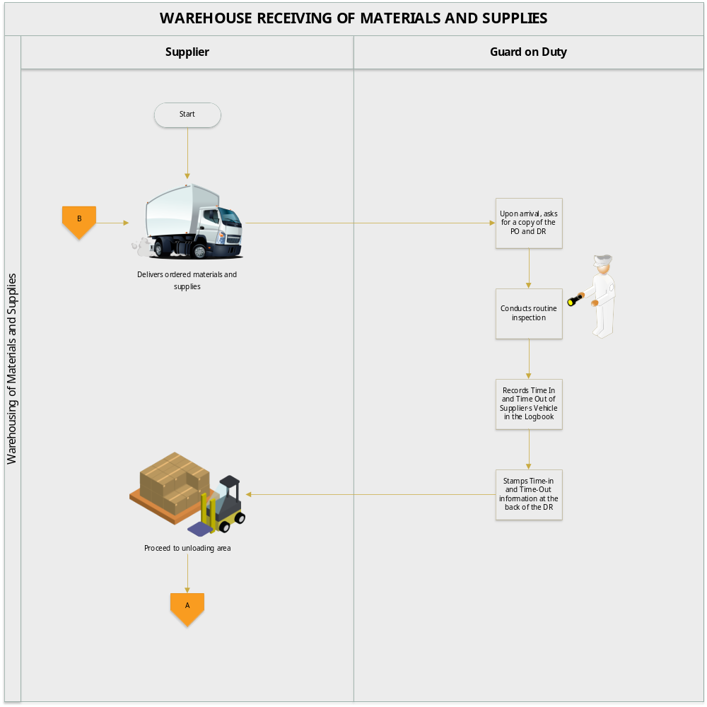

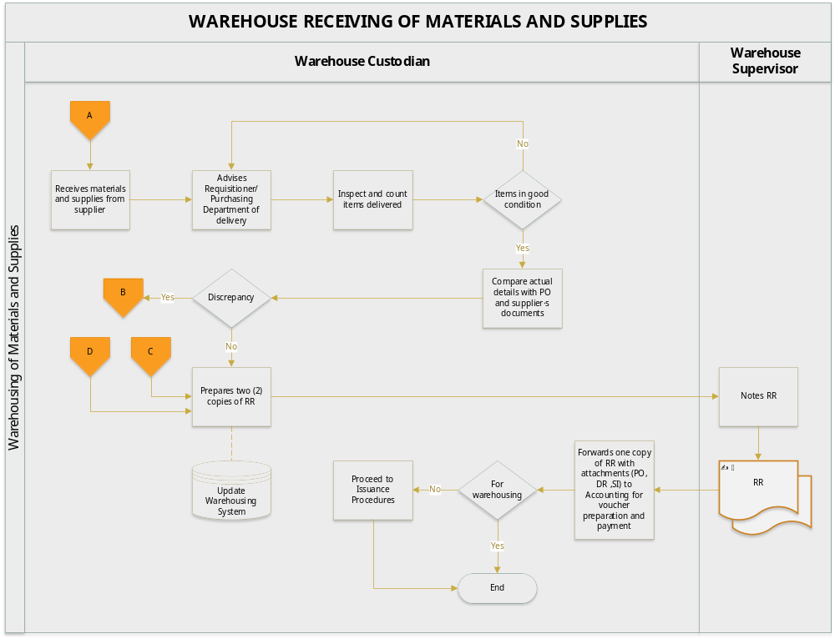

  - On-Site Receiving and Issuance of Materials and Supplies

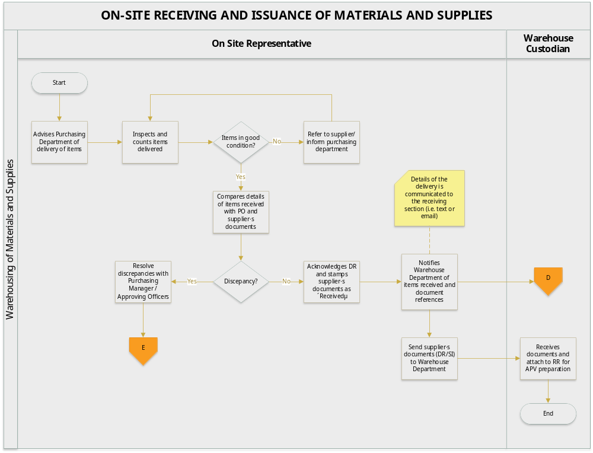

  - Discrepancy on Items Delivered

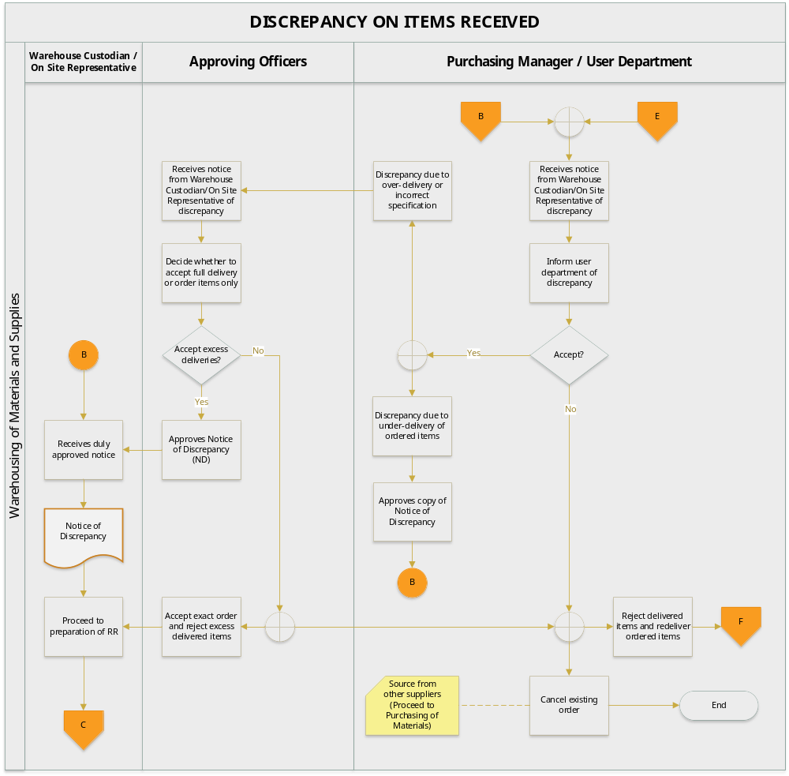

  - Direct Transfer of Materials and Supplies

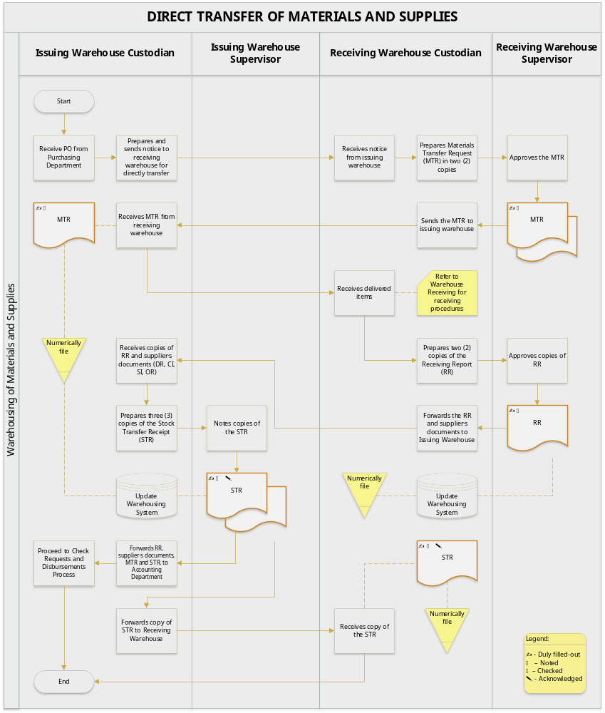
  - Inventory Count Procedures

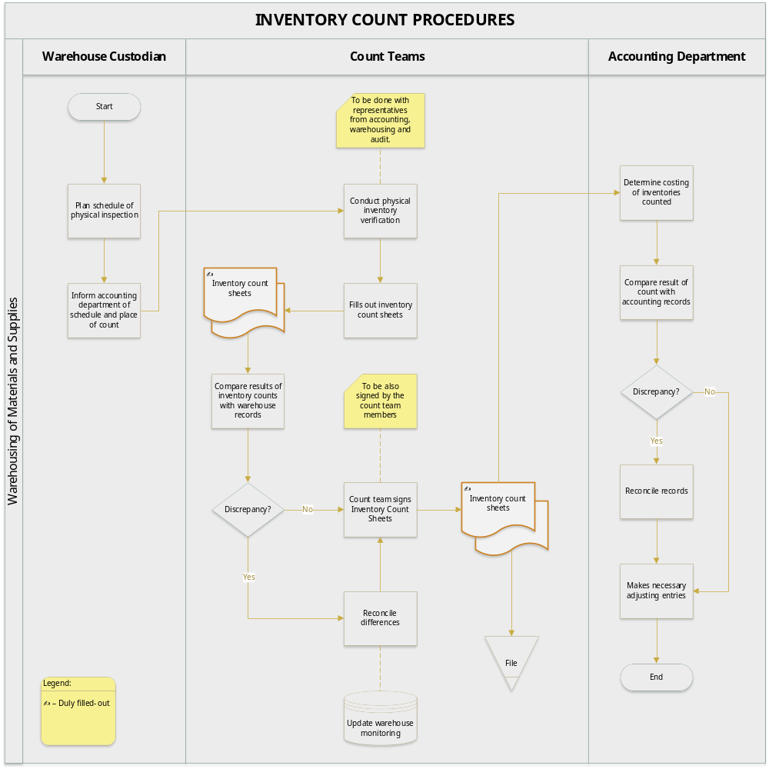

  - In-House Issuance of Materials and Supplies

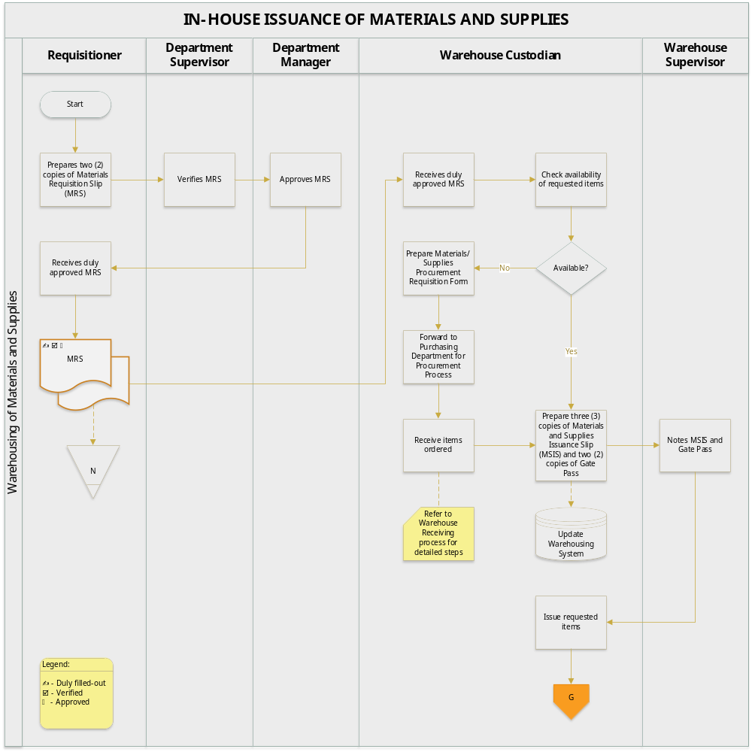

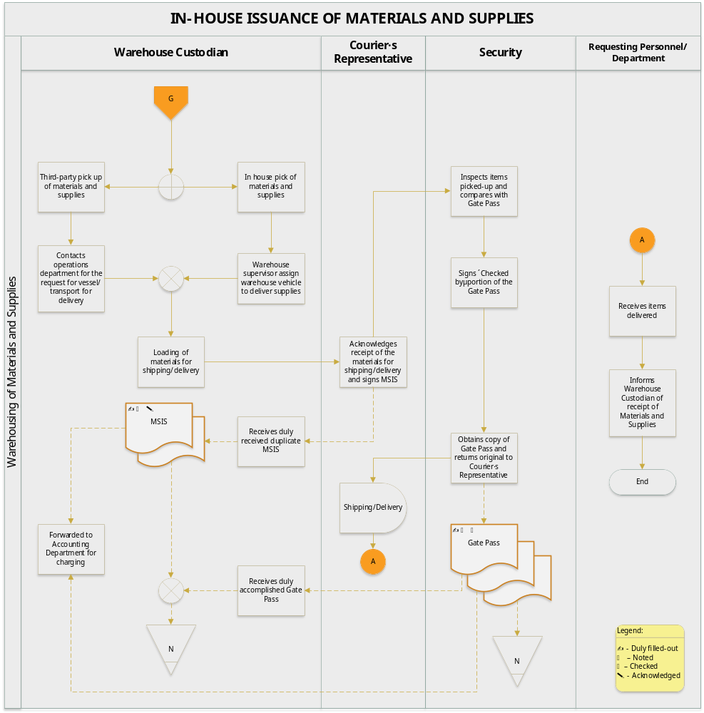

  - Inter-Warehouse Transfer of Materials and Supplies

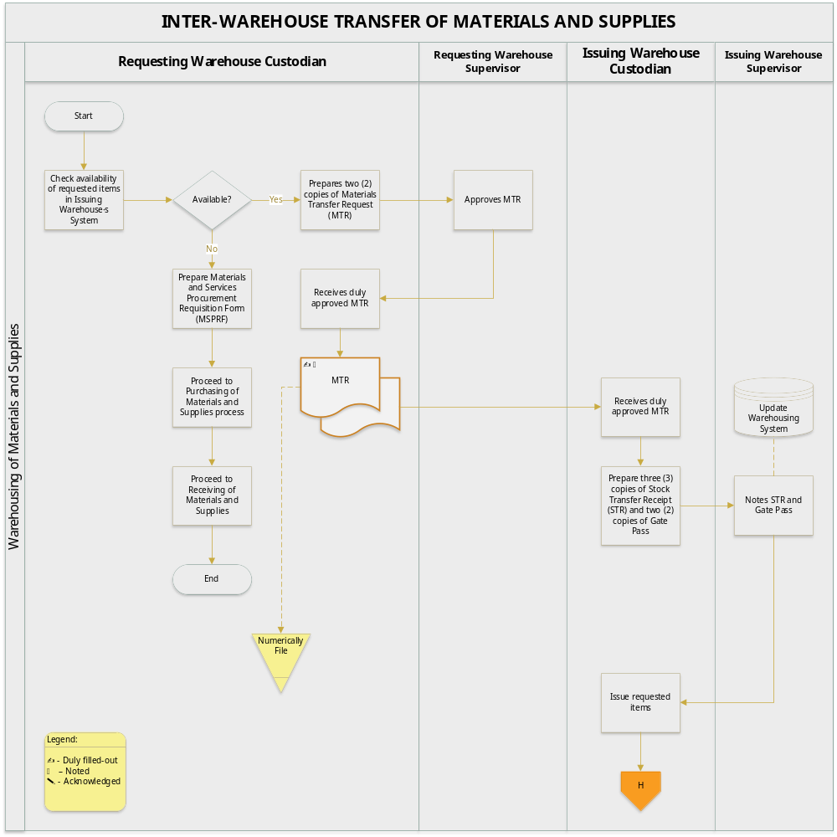

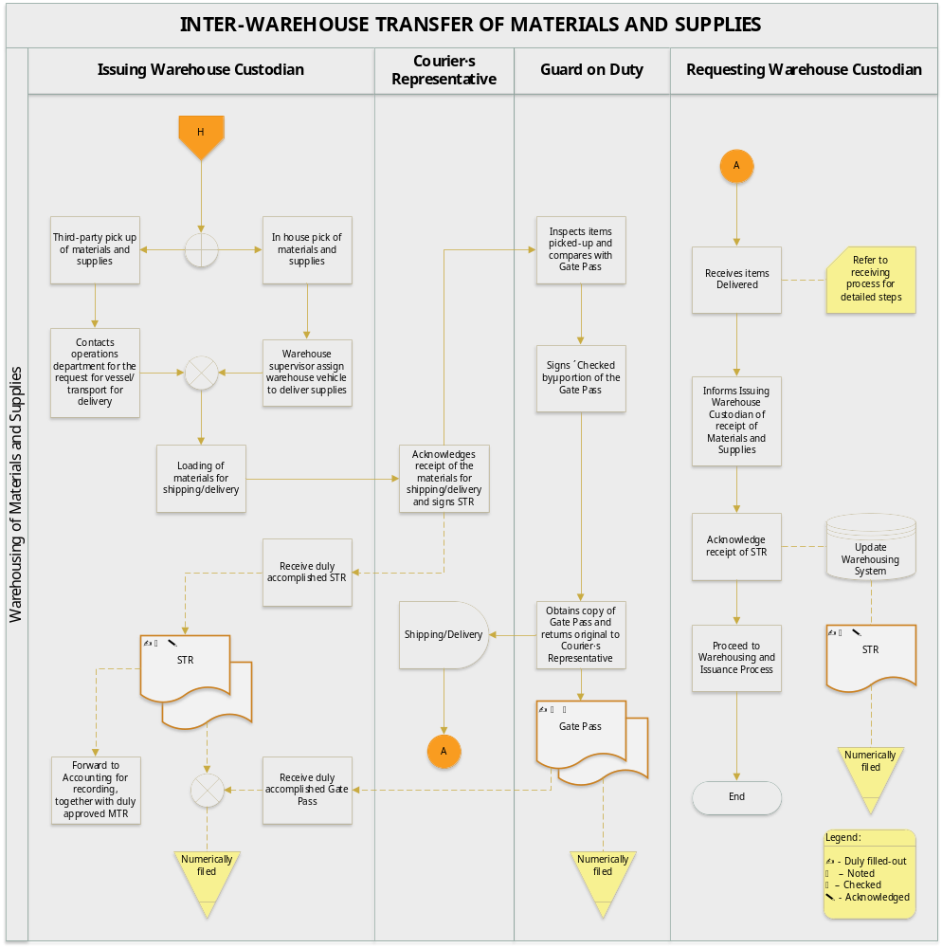

  - Inter-Company Issuance of Materials and Supplies

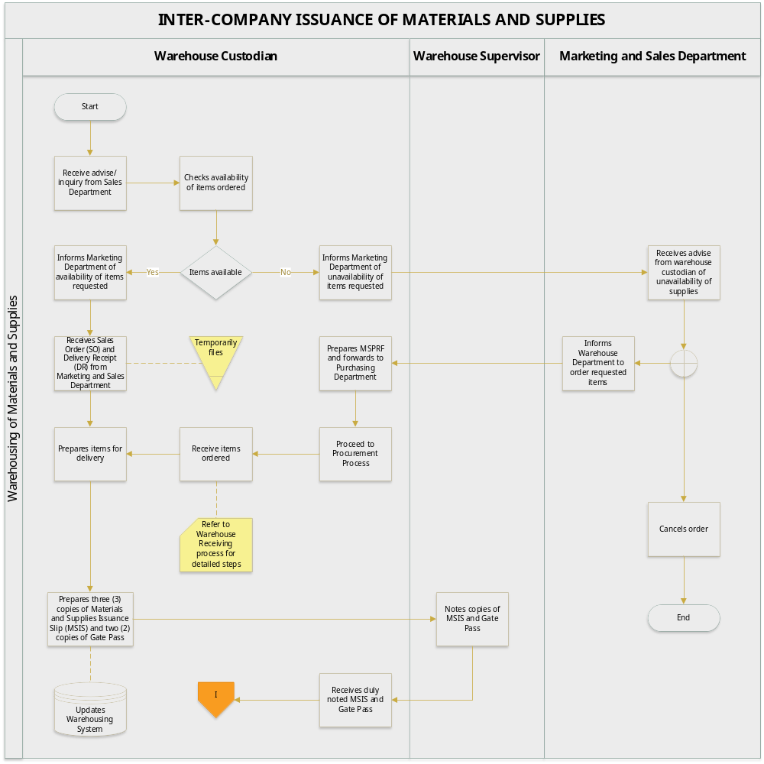

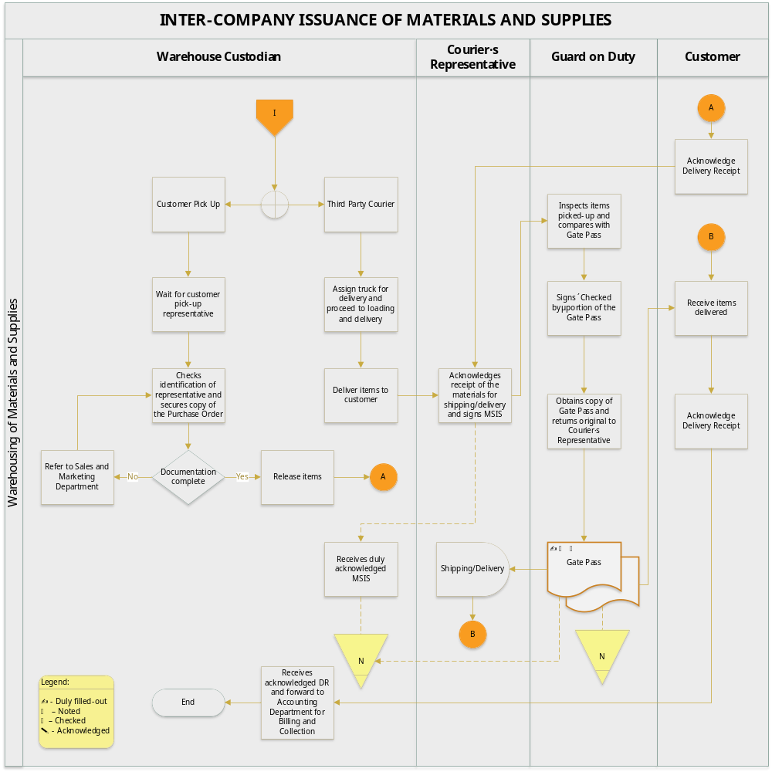

- BUSINESS FORMS

  - Receiving Report

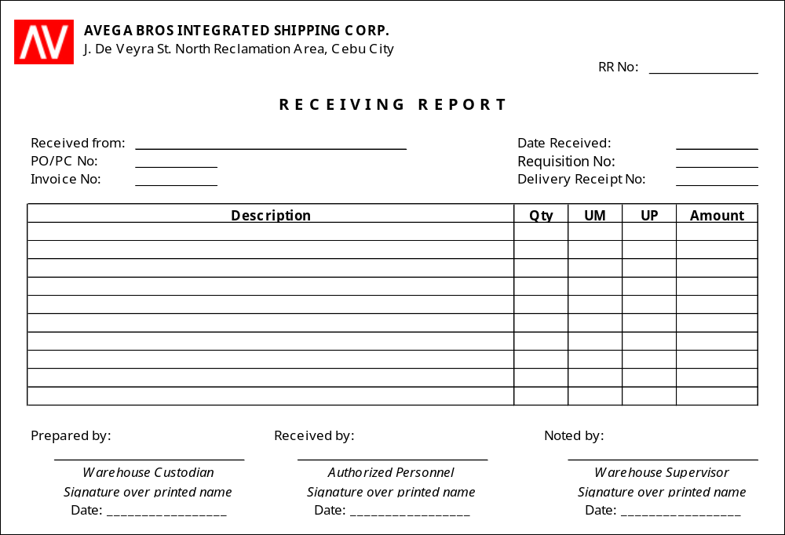

No. of Copies/color - 2
Explanation - this is prepared for items/materials received
Prepared by - Warehouse Custodian
Received by - Authorized Personnel
Noted by - Warehouse Supervisor
Distribution - RR 1 - Accounting Department (attached to the CkV)
RR 2 - Warehouse (filed numerically)

  - Inventory Count Sheet

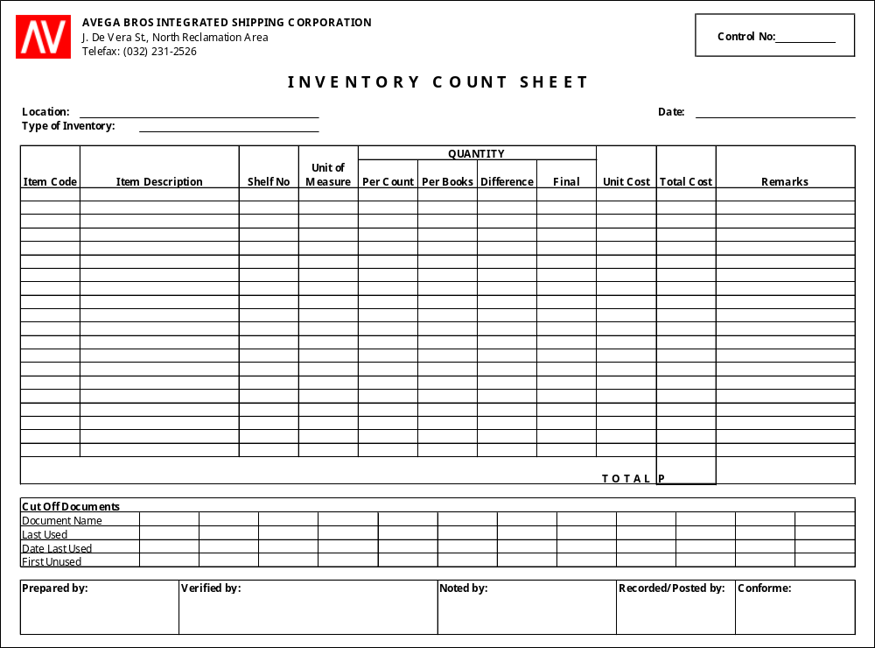

No. of Copies/color - 3
Explanation - this is prepared to document the physical verification of materials and supplies
Prepared by - Count Team
Verified by - Accounting / Audit
Noted by - Warehouse Supervisor
Recorded/Posted by - Accounting / Inventory Bookkeeper
Conforme - Warehouse Custodian
Distribution - White - Accounting Department
Yellow - Warehouse Department
Pink - Audit

  - Monthly Inventory Report

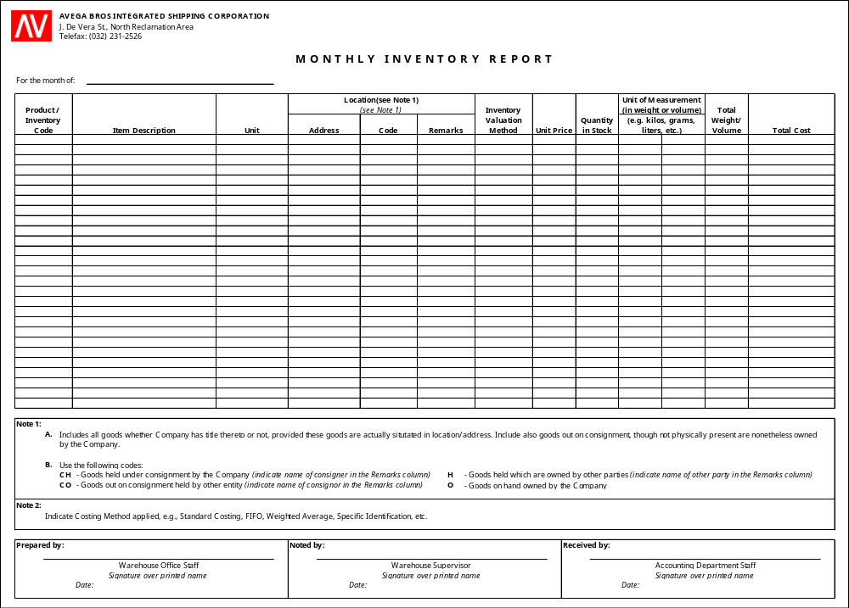

No. of Copies/color - 2
Explanation - this is prepared monthly to update the accounting department of the level of materials and supplies on hand
Prepared by - Warehouse Office Staff
Noted by - Warehouse Supervisor
Received by - Accounting Staff
Distribution - MIR 1 - Accounting Staff
MIR 2 - Warehouse Department

  - Materials Requisition Slip

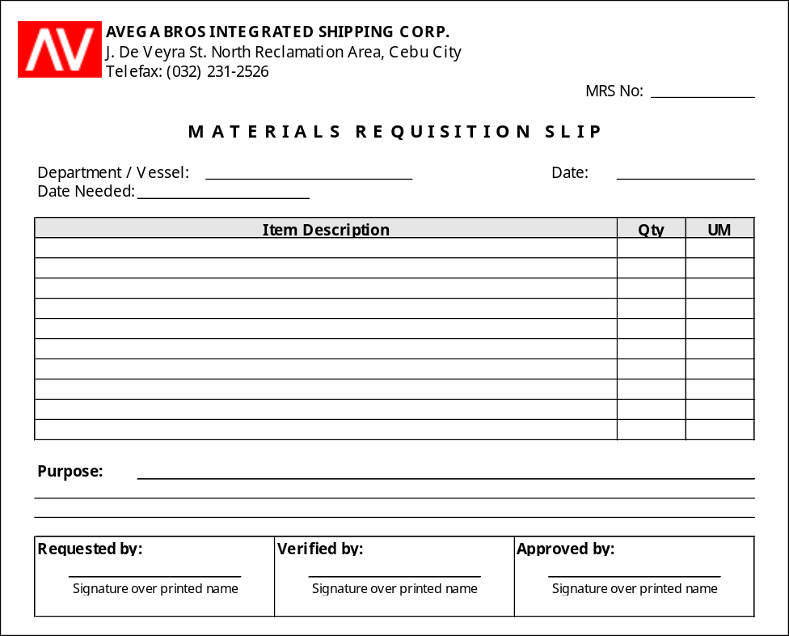

No. of Copies/color - 2
Explanation - this is used to request materials and supplies from the warehouse
Prepared by - Requisitioning Personnel / Department
Verified by - Department Supervisor
Approved by - Department Manager
Distribution - MRS 1 - Accounting Staff
MRS 2 - Warehouse Department

  - Materials Transfer Request

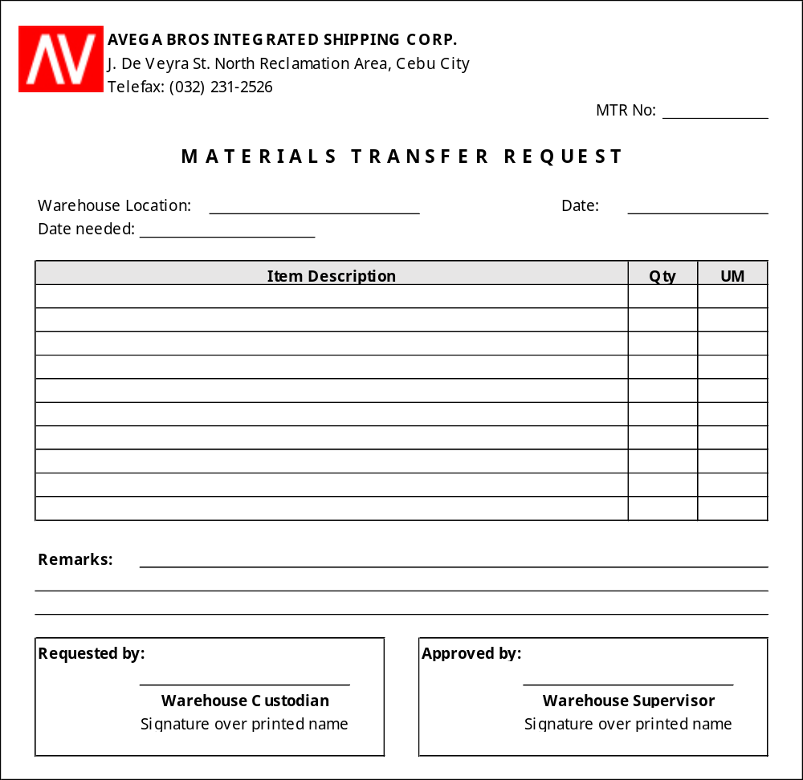

No. of Copies/color - 2
Explanation - this is used to request transfer of materials and supplies from the one warehouse to another (e.g. Makati Warehouse to Cebu Warehouse)
Requested by - Requisitioning Warehouse’s Custodian
Approved by - Requisitioning Warehouse’s Supervisor
Distribution - MTR 1 - Accounting Staff
MTR 2 - Issuing Warehouse Department

  - Materials and Supplies Issuance Slip

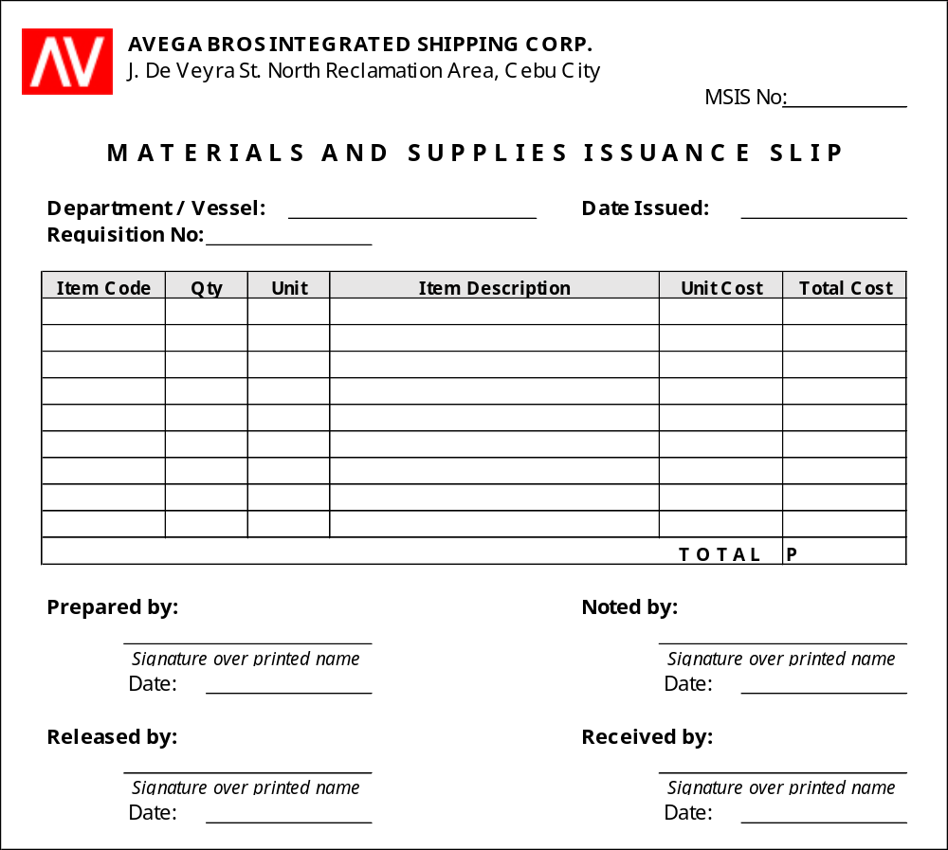

No. of Copies/color - 3
Explanation - this is prepared upon issuance of requested materials and supplies
Requested by - Warehouse Custodian
Released by: - Warehouse Staff / Authorized Issuing Personnel
Noted by - Warehouse Supervisor
Received by - Authorized Receiving Personnel
Distribution - MSIS 1 - Warehouse Department
MSIS 2 - Accounting Department (together with attached MRS)
MSIS 3 - Receiving Personnel

  - Stock Transfer Receipt

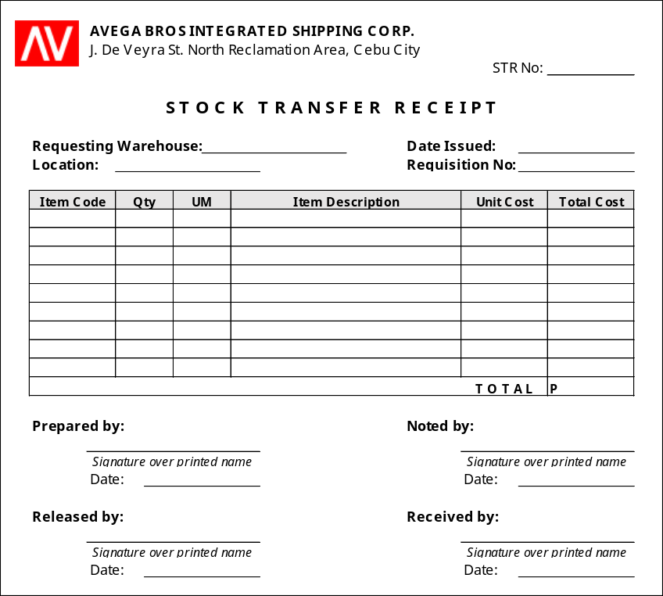

No. of Copies/color - 3
Explanation - this is prepared upon transfer of requested materials and supplies
Requested by - Issuing Warehouse Custodian
Noted by - Issuing Warehouse Supervisor
Received by - Requesting Warehouse Custodian
Distribution - STR 1 - Issuing Warehouse (file copy)
STR 2 - Accounting Department (together with attached MTR)
STR 3 - Requesting Warehouse (file copy)

  - Delivery Receipt

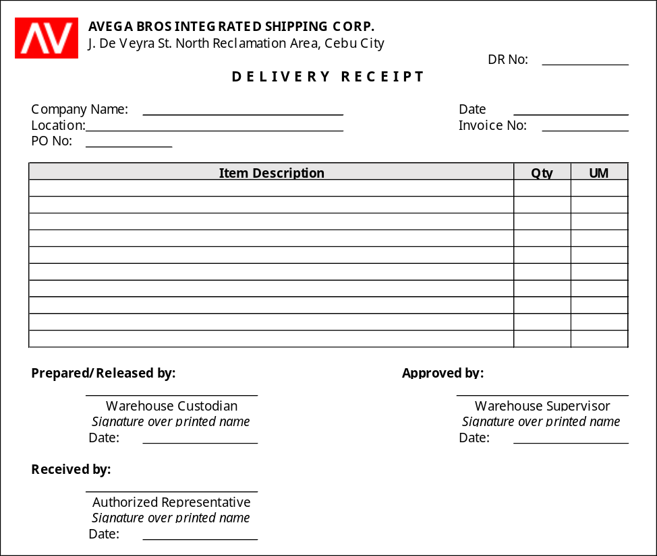

No. of Copies/color - 3
Explanation - this is prepared upon delivery of items per sales order
Prepared/Released by - Warehouse Custodian
Approved by - Warehouse Supervisor
Received by - Customer’s Authorized Representative
Distribution - DR 1 - Customer
DR 2 - Warehouse Department
DR 3 - Accounting Department

  - Materials and Supplies Return Slip
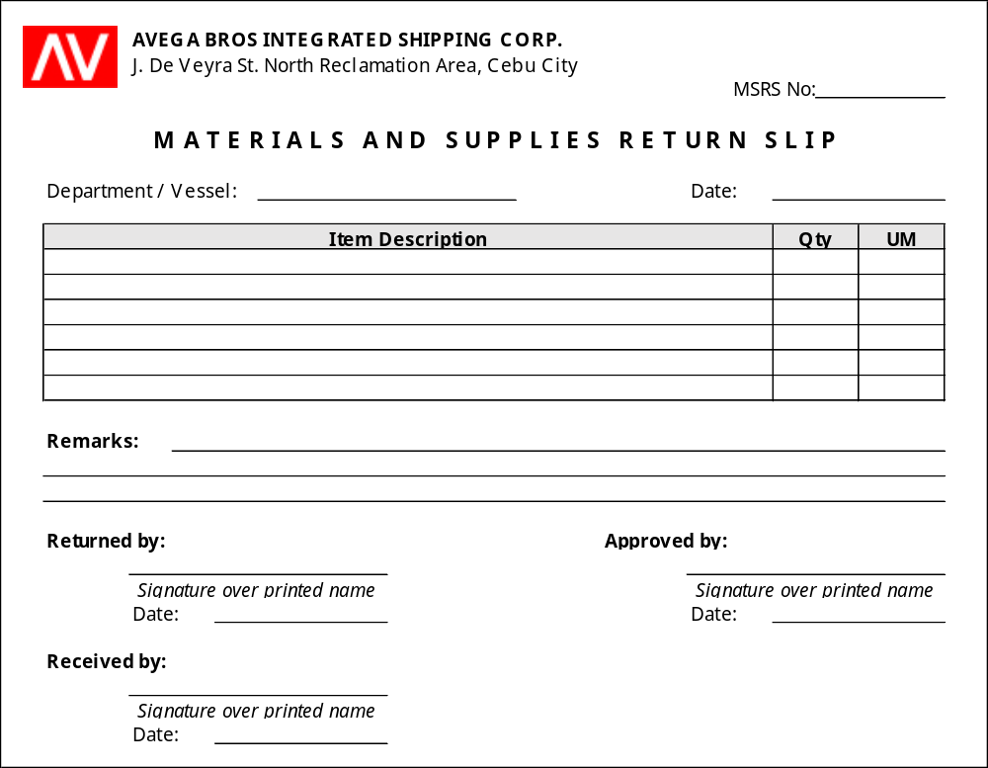

No. of Copies/color - 2
Explanation - this is prepared upon return of unused materials and supplies back to the originating warehouse
Returned by - Requisitioner
Approved by - Department Manager
Received by - Warehouse Custodian
Distribution - MSRS 1 - Accounting Department
MSRS 2 - Warehouse Department

  - Stock Card

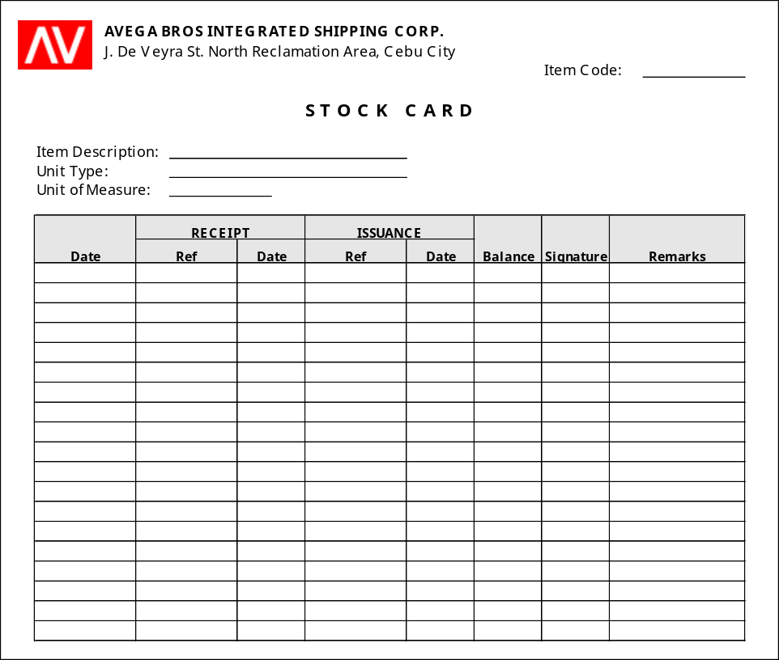

No. of Copies/color - 1
Explanation - this is prepared to monitor the receipt and issuance of materials and supplies in the warehouse
Signature - Warehouse Custodian (receiving and issuing staff)

  - Gate Pass

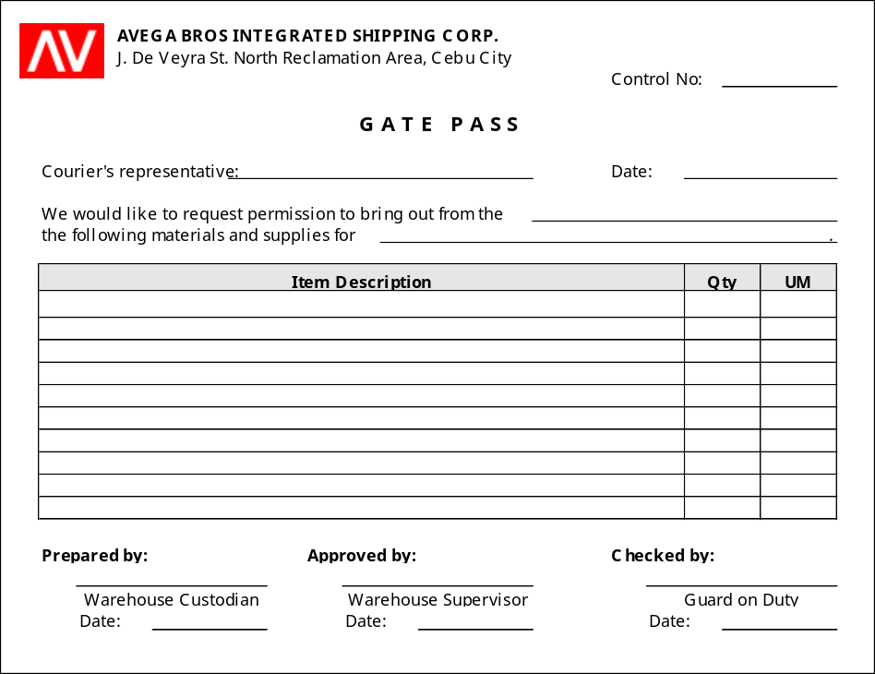

No. of Copies/color - 3
Explanation - this is issued to the courier’s representative for issuances of materials and supplies which need to be brought out of the warehouse premises
Prepared by - Warehouse Custodian
Approved by - Warehouse Supervisor
Checked by - Guard on Duty
Distribution - White - Courier’s/Supplier’s Representative
Blue - Guard on Duty
Pink - Warehouse Department

  - Notice of Discrepancy

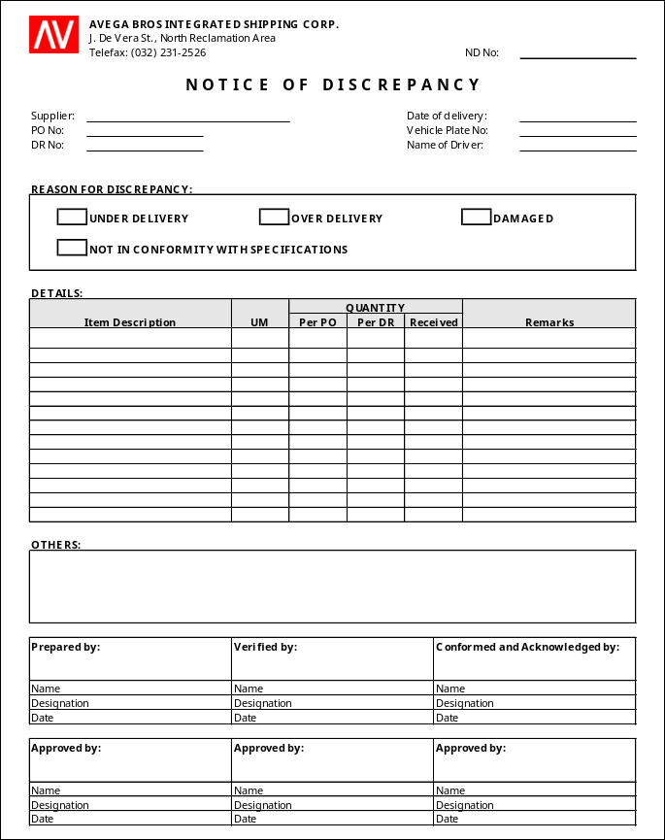

No. of Copies/color - 2
Explanation - this is prepared when delivered items which contains discrepancy (quantity or specification) with the requested items in the PO are accepted
Prepared by - Warehouse Custodian
Checked by - Warehouse Supervisor
Approved by - If over-delivery, authorized approving officers of MSPRF, PO, and Finance Manager (refer to section V.I.1, page 8, of the process title “Purchasing of Materials” for the MSPRF and PO authorized approving officers)
If under-delivery, Purchasing Manager
Distribution - White - Warehouse Department
Blue - Purchasing Department
Yellow - Accounting Department (attached to the PO and supplier’s documents)

  - Materials and Supplies Disposal Form (MSDF)

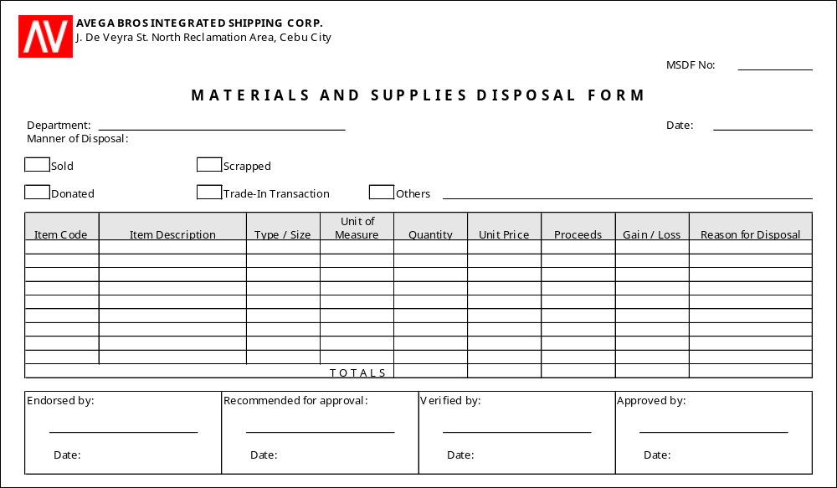

No. of Copies/color - 2
Explanation - this is prepared upon request of disposal of warehouse materials and supplies
Endorsed by - Warehouse Custodian
Recommended approval by - Warehouse Supervisor
Verified by - Engineering Manager
Approved by - SVP / President
Distribution - White - Accounting Department
Blue - Warehouse

- EFFECTIVITY

This Policies and Procedures Manual shall take effect upon approval and shall supersede any memorandum/SOP inconsistent with this Policies and Procedures Manual. Any changes to the manual shall comply with the policies and procedures indicated in the process title “Amendment of Manual”.

